Board of Directors Meeting Minutes
Date: 1/22/24

Time: 6:00 pm
Location: Science Classroom - Southeastern Academy Charter School
Call to order: Meeting called to order at 6:00pm Misty Stone
Roll Call: Misty Stone
Board Members Present: Misty Stone, April Oxendine, Brian Glotzbach, Scott McLean, Paru Patel, Tanner Smith, Corey Walters

Board Members Absent: Adrian Lowery, Paul Bass, Lonnell Dixon

Others Present: Tanya Branch, Dr. Lewis Cox, Jackie Davis (parent), Erin Prevatte (teacher), Dawn Parker (parent), Sam Powers (parent), Alex Prevatte (parent), Tracey Jones (parent), Tadd Jones (parent)

Mission Statement: Misty Stone
Southeastern Academy Charter School will maintain high expectations and promote excellence, especially in the fields of math and science for all students. The school, within its rural community, will foster a caring and creative learning environment. The school emphasizes the social, emotional, physical, and intellectual development of each child. This will be obtained through learning experiences that help children reach their greatest potential in order to function as independent learners in a diverse and ever-changing society.
Vision Statement: Misty Stone
A Diverse Family of Learners that Seek to Challenge the Whole Child Through Innovation.

Approval of Meeting Minutes: Misty Stone
September 25, 2023 Minutes: Motion made by Scott McLean to approve minutes from September’s regular scheduled board meeting as presented; Paru Patel seconded. 0 abstain, 0 No, All in favor, motion carried.

October 2nd, 2023: Motion made by Paru Patel to approve minutes from October’s special called meeting as presented; Corey Walters seconded. 0 abstain, 0 No, All in favor, motion carried.

November 20th 2023 : Motion made by Paru Patel to approve the minutes from November’s special called meeting; Scott McLean seconded. 0 abstain, 0 No, All in favor, motion carried.

Statement of Public Comments Misty Stone
Preamble statement read for bringing forth public comments (see below)

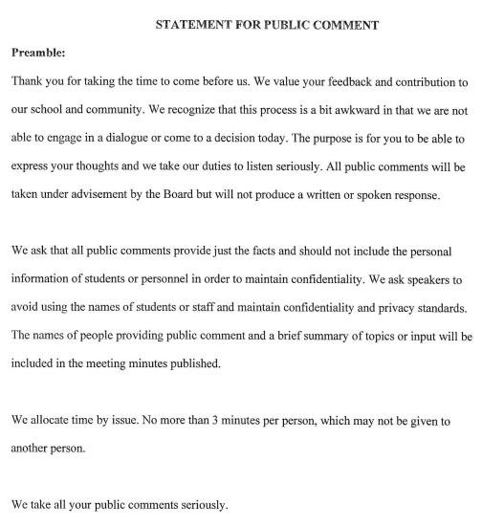

Public Comments as follows:

Public Comment made by: Jackie Davis (parent): The parent brought forth her concerns regarding not having a full-time EC teacher.

Public Comment made by Erin Prevatte (teacher): The teacher addressed the board regarding proposed school and board improvements.

Exceptional Children’s Program Update: Dr. Cox
Mrs. Karen Jacobs began January 2nd at SeA as the part-time EC teacher. Mrs. Jacobs is certified in EC. She is also part-time at Old Main Charter School. She can only work 30 hours per week between both schools. She will be at SeA four days a week. Currently in the EC classroom is Ms. Griffin, Ms. Bryant and Mrs. Jacobs.

Committee Reports:
- Finance Committee: No report

- Policy Committee: Corey Walters reported on quite a few policies that had been update.

Parent Bill of Rights to be effective by July 1st. Every school district around the state has approved this policy. Will review and vote on at March meeting.

Hours, Attendance, Meetings and Leave for Teacher/Staff added the addition as follows,
- No more than 3 personal days can be taken consecutively unless it is an emergency situation, e.g., death of an immediate family member.
- Three consecutive days absent without notifying the School, it is assumed that you have voluntarily abandoned your position with the School, your employment with the school is terminated and you can be removed from the payroll.
- Due to testing no personal days are allowed to be taken after 5/1/24 unless approved by Principal prior to.
Motion made by Tanner Smith to accept the policy; Second by Scott McLean. 0 abstain, 0 No, All in favor, motion carried.

Social Media Policy has been revised and approved by the Charter’s attorney. The updated policy comes as a recommendation from the Policy Committee; Tanner Smith seconded; 0 abstain, 0 No, All in favor, motion carried.

Employee Handbook (Telework): The policy committee brought forth a recommendation for the removal of the telework language from the employee handbook. The updated policy comes as a recommendation from the Policy Committee; Scott McLean seconded; 0 abstain, 0 No, All in favor, motion carried.

- Education Committee: Paru Patel reported the NC Checkin-2 data. The board received a handout and there was a one-point increase with Reading and fifteen-point increase with Math and Science.

Principal’s Report: Dr. Lewis Cox
- Personnel: Still advertising for a Certified EC Teacher. Retired Math Teacher is tutoring a few days a week at the school.
- Grant: LREMC grant was approved and three other grants are pending.
- Check-ins: Was great to see the growth.
- Upcoming Events:
January 26- Student Letter of Intent Due
January 28-30 Beta Convention
February 1- Lottery Opens, Closes March end of March 28. April 11 at 2:00pm Sherriff Wilkins and Lottery Drawing.
February 6- Early College on Campus talk with 8th Grade
February 9- Progress Reports
February 12- Upcoming 4th Grade NAEP Reading and Math
February 15- BINGO and Silent Auction at 6pm
February 27- Sports Pictures and 8th grade pictures
February 29-Wax Museum 3rd-5th grade
February – March: Soccer
March 11-15: Check-In #3

Finance & Repair(s): Tanya Branch
Received a handout regarding Financials as of December 31st 2023.
SeA is doing well with spending and was able to repair the driveway with a lot of help from OPTS funding.

Motion to Enter Closed Session:
At 6:35pm Paru Patel made a motion to go into Closed Session; Tanner Smith seconded. 0 abstain, 0 No, All in favor, motion carried.

Board of Directors Meeting Minutes
(Open Session from Closed Session, January 22nd 2023)

Misty Stone open the meeting from closed session to open session at 7:22pm.

The board open the meeting due to voting on the polices did not conclude with “all in favor”

Parent Bill of Rights

The group decided to move forward to adopting this policy due to this is a state policy and no changes can be made. Tanner Smith motion to adopt the Parent Bill of Rights policy, seconded Brian Glotzbach. All in favor; motion carried.

Hours, Attendance, Meetings and Leave for Teacher/Staff

The board member are all in favor of this policy and motion carried.

Social Media Policy

The board members are all in favor of this policy and motion carried.

Due to conflict with Dr. Cox’s schedule, the next school board meeting will be March 18th 2024 instead of March 25th 2024.

Corey Walters made a motion to change the date, seconded Peru Patel. All in favor; motion carried.

7:30pm Peru Patel made the motion to adjourn the meeting and Scott McLean seconded. All in favor; motion carried.

