Board of Directors Meeting Minutes
Date: 9/25/23

Time: 6:00 pm
Location: Gym - Southeastern Academy Charter School

Call to order: Meeting called to order at 6:00pm Misty Stone

Roll Call: Misty Stone
Board Members Present: Misty Stone, Adrian Lowery, April Oxendine, Paul Bass, Brian Glotzbach, Scott McLean, Paru Patel, Tanner Smith, Corey Walters

Others Present: Tanya Branch, Dr. Lewis Cox, Ms. Fountain, Ms. Jones, Ms. McIver, Ms. Meroney

Board Members Absent: Lonnell Dixon

Mission Statement: Misty Stone
Southeastern Academy Charter School will maintain high expectations and promote excellence, especially in the fields of math and science for all students. The school, within its rural community, will foster a caring and creative learning environment. The school emphasizes the social, emotional, physical, and intellectual development of each child. This will be obtained through learning experiences that help children reach their greatest potential in order to function as independent learners in a diverse and ever-changing society.

Vision Statement: Misty Stone
A Diverse Family of Learners that Seek to Challenge the Whole Child Through Innovation.

Approval of August 21st 2023 Meeting Minutes: Misty Stone
No edits were needed. Motion made by Scott McLean to approve the August 21st meeting minutes; Paru Patel seconded the motion. All in favor; motion carried.

Preamble statement read for bringing forth public comments: Misty Stone
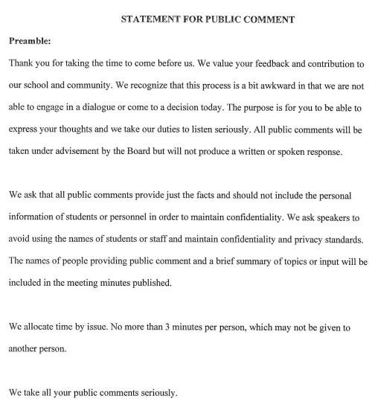

Public Comments as follows:

Public Comment made by: Katie Fountain (former parent). The parent spoke about how her child used to be in the EC program at SeA and shared concerns about using the EC classroom for ISS.

Public Comment made by: Tracey Jones (parent). The parent shared her concerns about not having a full-time EC teacher.

Public Comment made by: Selina McIver (parent). The parent shared her concerns about the personnel change with the former full-time EC teacher; she felt the change was made quickly, and it didn’t give her child time to adjust to the change.

Public Comment made by: Becca Meroney (former teacher). The former teacher spoke about the duties she undertook while being the EC Teacher in addition to various concerns she had with the EC program under the current leadership.

Committee Reports:

- Finance Committee: No report; the committee will meet on January 22nd at 5:30pm.

- Policy Committee: Corey Walters reported that board members who serve and fulfill obligations that their children will be allowed to attend SeA have been revised and will need to be voted on.

- Education Committee: Paru Patel reported the following for 3rd Grade BOG Data:
Of the 24 students who tested, 10 students were not proficient; 4 students scored Level 3; 2 students scored Level 4; 2 students scored Level 5; 4 Students met Career and College Readiness (4’s and 5’s); 8 Students met Grade Level Standards (3’s, 4’s, and 5’s). Numbers are low but we should see improvements with the EOG.

Principal’s Report: Dr. Lewis Cox

- Dr. Cox presented a PowerPoint of the 2023 School Performance.

- We have an EC full-time vacancy; the position is posted online and is being advertised on social media; a few individuals have shown interest and will be followed up with. There are contract services in place to help with student support and IEPs.

- October 5th is Curriculum Night @ 6:00; during this time there will be a review of teacher expectations with families. Resources will be provided to parents on how to support students.

- October 5th is an OPTS meeting at 5:30 to discuss upcoming fundraisers and student-led initiatives. A survey was sent out to parents asking for those interested in helping with OPTS to sign up.

- Projects: Water fountain/bottle filler in the cafeteria will (hopefully be installed this week; floors and halls are being buffed; pressure washing of the cement and corridors around campus; looking into quotes on expanding and repairing the exit drive in the parking lot.

- Cakes and Pasties will be an option on Mondays, Wednesdays, and Fridays along with Jersey Mike's on Tuesdays and potentially Chick-fil-A on Thursdays.

- October 16th is NC Check-In for Math & ELA - results will be presented to the board at the following board meeting.

- Article V – Meetings held virtually (if needed); reviewed Section 7 of the by-laws and agreed that the language already there is clear on virtual meetings and no changes are needed.

- Lottery Policy – This was revised to allow children of board members who serve and fulfill obligations to have direct admission to SeA.

Finance & Repair(s): Tanya Branch
As of Friday, September 22^{nd,} we do have the state budget, but nothing has been released. As of October 31st, we have $280,000 float money.

Motion for Closed Session:
Motion was made at 6:20 pm by Paru Patel to adjourn the open meeting and go into a closed session with a second by Tanner Smith. All were in favor; motion passed. SeA Board open meeting session was adjourned at 6:20pm by Misty Stone.
_____________________________________________________________________________

Following Closed Session: Meeting for open session called to order at 7:01pm by Misty Stone

Juneteenth National Independence Holiday:
A motion was made by Tanner Smith to approve the Juneteenth National Independence Holiday to be given to all SeA employees with a second by Paru Patel. All were in favor; the motion was passed.

Addendum from Lottery Policy:
A motion was made by Corey Walters to accept the revisions to the Student Administration and Leave Procedures and add an addendum from Lottery Policy, item 3; the motion was seconded by Tanner Smith; all were in favor; the motion passed.

Statement for Public Comment:
After a discussion with the Charter’s Attorney, she recommended the current Statement for Public Comment be updated. The suggested edit was the 4th paragraph to state “We take all your public comments seriously. The board will discuss and if there is an action that needs to be taken, it will be reflected in the minutes and communicated to you by the principal.” A motion was made by Scott McLean to accept the updated “Statement for Public Comment” with a second by Tanner Smith; all were in favor; the motion was passed. Misty Stone to ensure that the revised statement is posted on the SeA Board’s website.

Virtual Meetings (if needed):
The board discussed having emergency meetings virtually but ensuring there is a quorum for voting. No motion or vote needed as this was/is already in the bylaws.

Adjournment:
Motion made at 7:28pm by Tanner Smith to adjourn the meeting with a second by Paru Patel; all were in favor and the motion was passed. The meeting was adjourned by Misty Stone at 7:28pm.

The next board meeting will be January 22nd 2024 at 6:00pm.

